PRESIDENT’S REPORT
It has been a great honour to be President of such a wonderful Club and I would like to thank every member, past and present, and their partners for their enormous help and support to me during the year.
Such enthusiasm across all avenues of service resulted in our Club receiving a prestigious 2011–12 Changemaker Award from Rotary International for “making positive and significant changes in the community and the world”.
These changes have been substantial. Moreover, our enormously successful Bobbin Head Cycle Classic, which jointly raised with the Rotary Club of Turramurra $24,533 for Lifeline and Bo Hospital, did not prevent us from carrying out our normal projects. Our monthly Gordon Markets, for example, raised $15,000, Bowelscan raised $3,720 whilst we donated $4,000 to ShelterBox and aided by a $2,000 Simplified Grant we provided a much-needed bus for Eagles RAPS for $4,000.
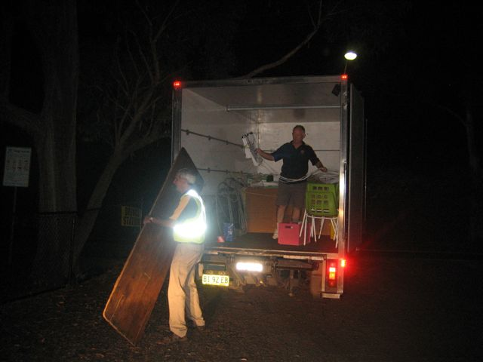
Members have worked extremely hard in promoting and supporting our Cycle Classic (even through the night), fundraising, encouraging our youth and raising Rotary awareness. Amongst others, Peter Kipps, Bob Ivey and Tony McClelland managed BHCC, its website and Koongga – for which we were runner-up to the prestigious Norm Roach Website Award – and worked on the club’s finances and weekly set-up. Geoff Hungerford’s secretarial, Gordon markets and audit work was also meritorious.
I have printed our calendar of events on the back cover of this Annual Report because it highlights in a very special and succinct way the complex, committed and continual involvement of Rotary Club of Ku-ring-gai members in projects across the board. It shows a full program of vocational, youth, international and community service, speakers, visits and projects and the amount of money which has been raised at each event.
Membership has stabilised and two more have been welcomed into our Rotary family. The Club is strong and able to take on new members and projects safe in the capable hands of your new President.
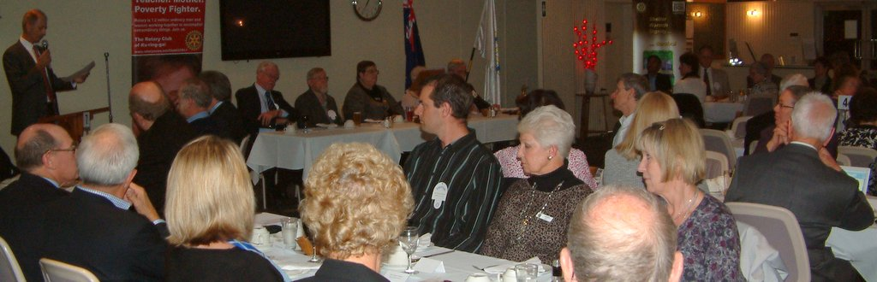
Caroline Jones (President)
ADMINISTRATION REPORT

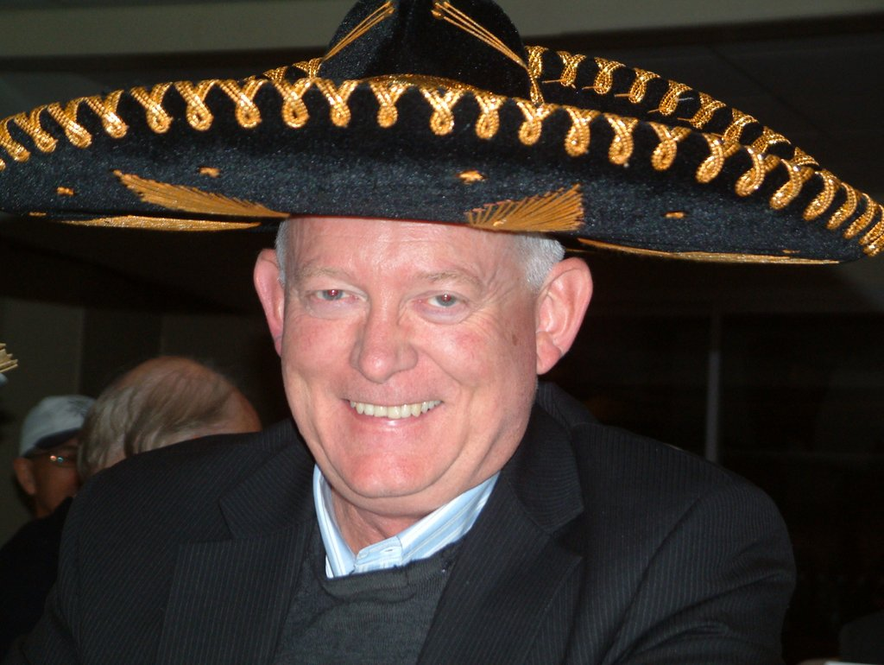
We have had a wide range of speakers this year, including talks on a number of local and international Rotary projects and representatives from a number of organisations such as the Spitfire Association and investment firms. Our own members gave a number of talks on their business experiences and their travels. Highlights of our member’s presentations were the very popular Graham Timms’ wine talks as well as the introduction to the social media phenomenon by Ross Lambert. A very interesting visit to Macquarie University Library took place, which was well supported and was very interesting. Thank you to all those who assisted in this speaker role. This year we had a Members’ Awareness Night to raise our profile in the local community. Thanks go to Michael Tyler for arranging the event and for all those Members who assisted in making the night such a great success.
Sergeant at Arms
Frank White started the year as Sergeant at Arms, but had to hand over to Greg Newling, as acting Sergeant at Arms, due to business commitments. Greg has provided a fun sergeant’s session each week in addition to increasing the Club’s financial position. Thank you Frank for your early work in that role as well as to Greg for taking on the role this year and for your enthusiasm in carrying it out so well.
Door Team
This is an important weekly role and this year we had a conscientious team of members doing door duty and greeting our visitors courteously and efficiently. Thank you to all.
Gordon Markets
This is our major fundraiser for the Club and requires a roster each month in 3 shifts to set up the markets, manage it through the day and then pack up at the end of the day. Geoff Hungerford, Graham Timms, Frank White and John Thompson consistently helped with putting up and taking down the banners and setting up and tidying away. Their commitment has been time consuming and ongoing and much appreciated. Also appreciated was the regular group of helpers on the rosters who reliably met their commitments during the day.
The Bulletin and the Club’s Website
A lot of effort has gone into the design and on-going publication of the weekly Koongga newsletter each week and this year it has been recognised by Rotary in the Norm Roach Web Site Memorial Shield, where we became runner-up with the note that “Ku-ring-gai’s site presents cleanly and attractively to the viewer”. Thanks go to Bob Ivey for his assistance in the ongoing work on the web site as well as to Tony McClelland for his commitment each week to getting the newsletter out on time.
Welfare
We continue to look out for opportunities to assist our former members and our members through times of difficulties and we thank Ted Price for his work in this area. Once again we held a Carers’ Night and thanks go to Irene Kennedy and Scott Drake for arranging this night.
Social Events
We continue to hold regular social events for our members and partners as they are always well supported. This year we have held Dinners for Eight, with members hosting these at their homes and guests assisting with the catering.
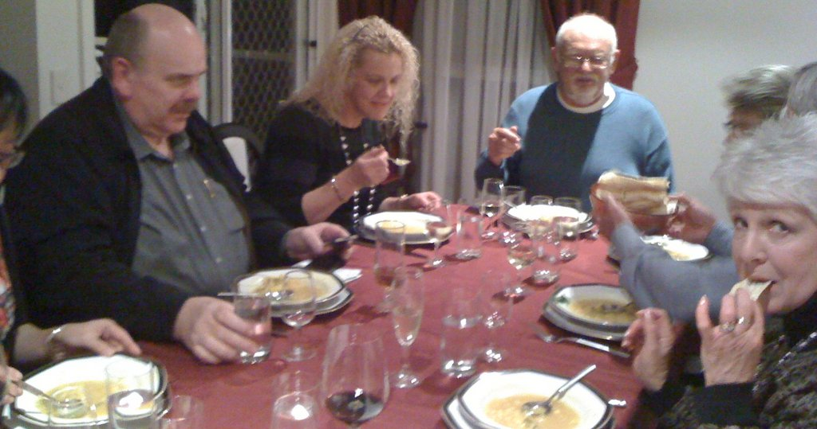
Trivia Nights
Ross and Helen Egan and Dilys Geddes and their helpers arranged a Trivia Night this year which was very well supported.
Movie Nights
This year we held a Movie Night at Roseville Theatre. The movie, “Late Bloomers”, was well received with around 200 attending the theatre that night and was a major fund raiser for the Club.
Restaurant Nights
We continue to hold dinners at different locations throughout the year for members and partners. These are always well supported.

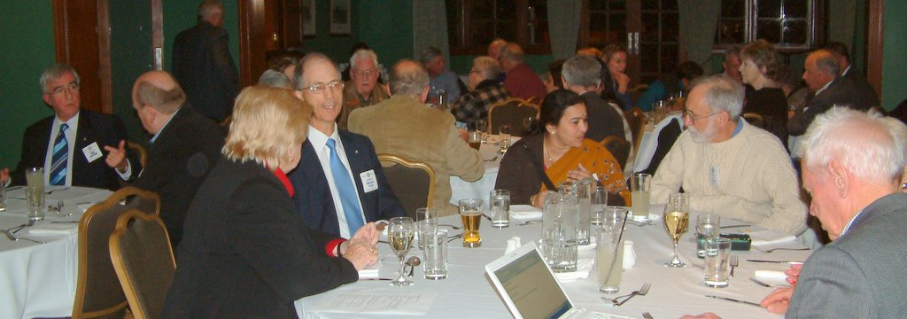

Debate Night
This year we challenged Turramurra Rotary to an annual debate night. Thanks go to Graham Timms, Irene Kennedy and Roger Desmarchelier for representing our Club at the debate and for winning the inaugural cup. Congratulations to all.
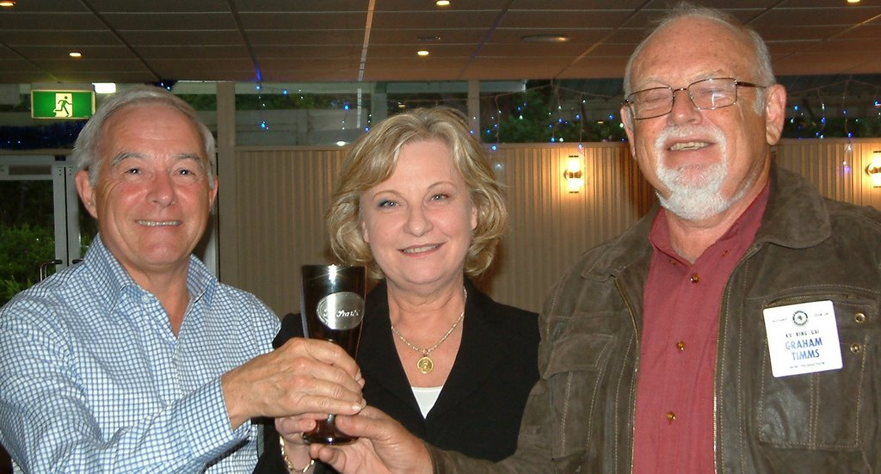
Catering
Each week our caterers face the challenge of providing a good meal to our members and guests at West Pymble Bowling Club. Thanks go to the Club for their assistance in providing the premises and service each week.

Secretarial Services
Geoff Hungerford has done a superb job efficiently and quietly complying with all that RI and District require on time and without fuss. Congratulations and thank you Geoff.

Finance
Our Treasurer, Tony McClelland, has been able to get our finances back into order and has presented financial reports to the Board monthly. Thanks go to Tony and Peter Kipps for their work in this area.

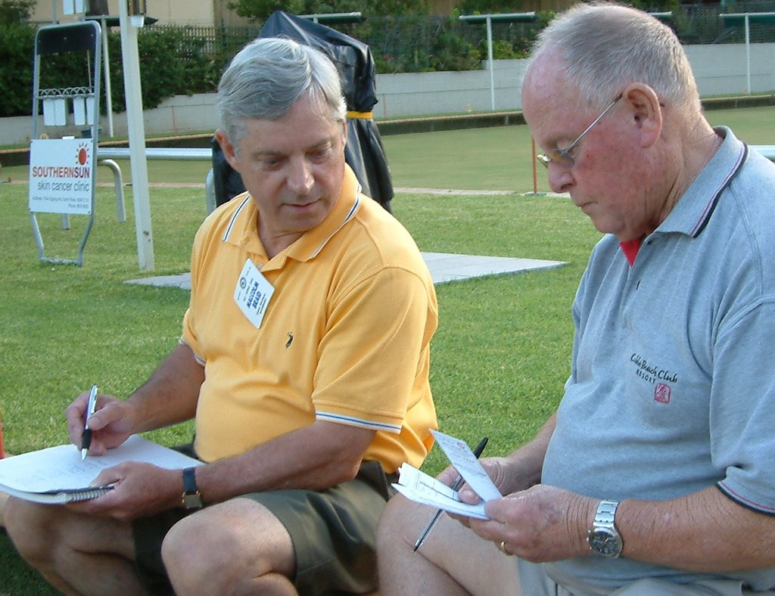
Bowling: Dilys Geddes, Roger Desmarchelier, Kerrie McCullough and Greg Newling won the President’s perpetual trophy for the Rotary Club of Ku-ring-gai Annual Sporting Team Challenge.
Behind the Scenes: Each week unrecognised Members assist in ensuring the meetings are run efficiently and to the timetable. Apart from the Sergeant at Arms, we thank Bob Ivey for providing and setting up the technology each week and for his important role in taking photographs of Club events.

Christmas Party
Thanks go to Michael and Louise Tyler for hosting the Christmas Party this year. It was a fun night.
Roger Desmarchelier (Club Administration Director)

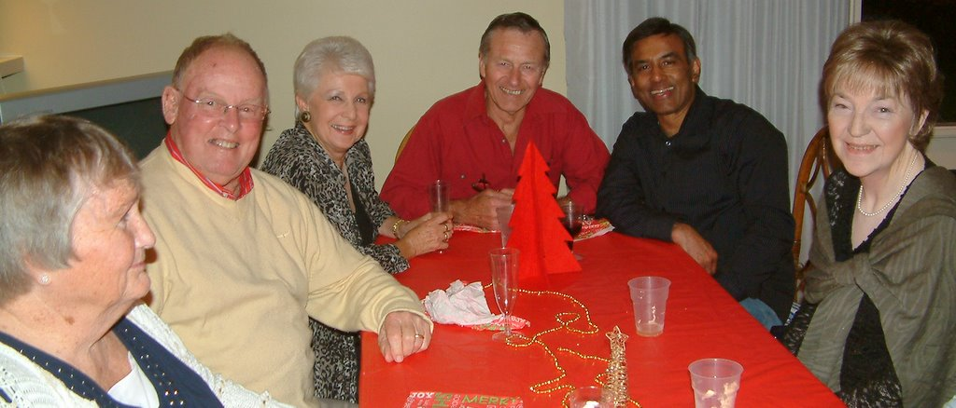

TREASURER’S REPORT
The Gordon Markets and the Bobbin Head Cycle Classic were our major Fund Raisers for the year. Income from the Gordon Markets will be $15,000. Our partnership in BHCC with the Rotary Club of Turramurra resulted in a distribution of $24,533 to Lifeline and Bo Hospital. This was an outstanding result for our first year and we expect a significant improvement next year.
The General Account had an opening balance of about $16,000 and will have a closing balance of about $16,000 when all expenses have been paid. The Project Account had an opening balance of about $15,000 and when all final expenses and donations have been submitted we will have a closing balance of approximately $19,000.
The club maintains a Project Account reserve fund with St George Bank and the closing balance was $23,667.
Membership dues have been paid promptly by the majority of our members.
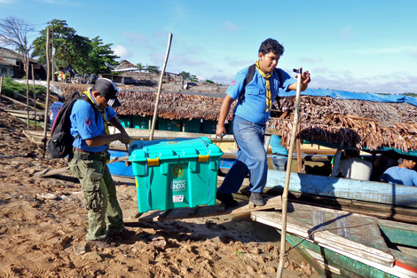
International Service Donations
These included School of St Jude $1,440, ROMAC $1,000, Rotarians against Malaria, $1,000 and Shelterbox, $4,000.
New Generations Service Donations
These included MUNA $250, Ku-ring-gai Creative High School $60.00, Killara High School $60.00, Turramurra High School $60.00, Clarke Road School $60.00 & Rotary Youth Leadership Awards $799.

The New Generations Committee also donated Youth Insearch $250, RYDA $200, $600 to Camp Breakaway and $100 to Life Education. They were successful in negotiating a Simplified Grant in which they received $2,000 and donated $2,000 so that Eagles RAPS could inherit a Bus from Clarke Road School.

Community Service donations included their great effort of raising $3,720 again for Bowelscan.
The Trivia Night raised $2,582.50 and the Movie Night $723.00 which will go to Polio Plus. We are reliant on our members’ participation and we are most grateful for all of the Club’s support. Speakers Recognition of just over $1,000 will also be donated towards Polio Plus, which will give a grand total of $4,305.50.
In summary, the Club’s bank accounts have maintained a good working balance while the avenues of service have largely achieved their goals. The Rotary Club of Ku-ring-gai has again shown great community responsibility.
Tony McClelland (Treasurer)

THE ROTARY FOUNDATION
The Foundation Committee’s aims for the year were:
- Raising the awareness of the Rotary Foundation and encouraging the support of projects the Foundation supports;
- Support for the Foundation through the Annual Programs Fund;
- Continuing to support the Polio Plus $200m Challenge;
- Seeking nominations for Rotary’s educational programs.

Raising Awareness of TRF
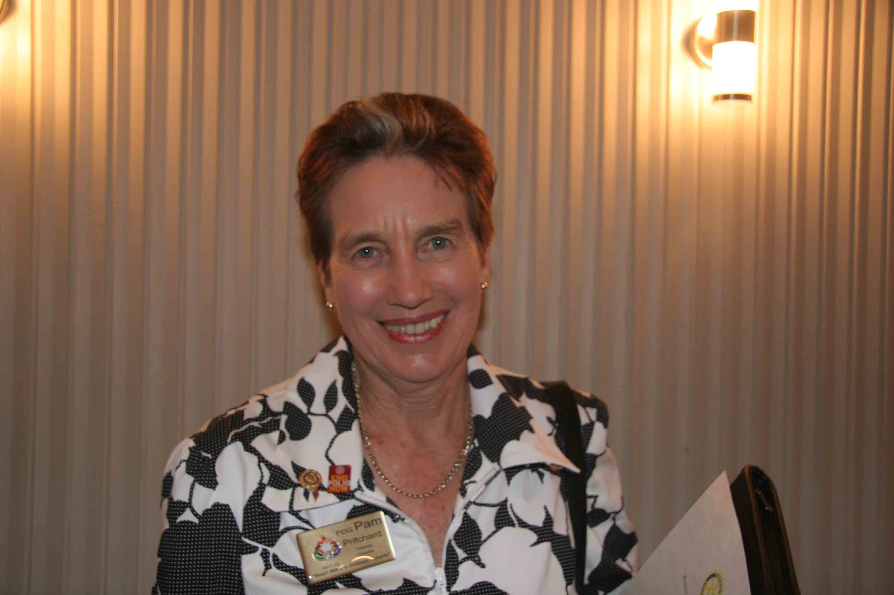
PDG Pam Pritchard gave us an update on the progress of the Polio Plus Program and the key focus areas. When Rotary launched this program in 1985 there were over 350,000 cases of polio each year. India has been declared polio free but polio is still endemic in Nigeria, Pakistan and Afghanistan.
It is the hard-to-reach areas that are providing the most challenges and a couple of those areas are also very insecure. We still have the challenge of eliminating Polio around the world and maintaining the focus to ensure that it does not reappear.

Thanks to Tony McClelland for his continued inclusion of the Rotary Thought for the Week.

Polio Plus
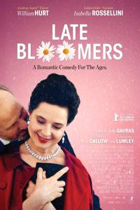
The Rotary Club of Ku-ring-gai continues to support the Polio Plus Program. Our cinema and trivia nights have been the main fundraising activities that support this wonderful program. That is why it is important for us all to support these events which provide visibility to a greater audience of the work Rotary is doing in the eradication of polio.
The success of these fundraising nights has been down to the great organisational skills of Ross and Helen Egan. A big thank-you also goes to Graham Timms, Greg and Joy Newling, Malcolm Braid, Richard and Sally Maloney and Lou and Rita Coenen for their donations of raffle and auction prizes. It is also important to recognise the contribution by several members and their partners who generously supported the catering requests and brought along friends to these events. Thank you all. Without you, your family and friends these events would not have been so successful. Nor would we have had so much fun.

Support of the Annual Programs Fund
The members of the Club have contributed nearly $1,200 to the Annual Programs Fund as part of the Centurion Program where members can make a tax deductible contribution of $100 each year.
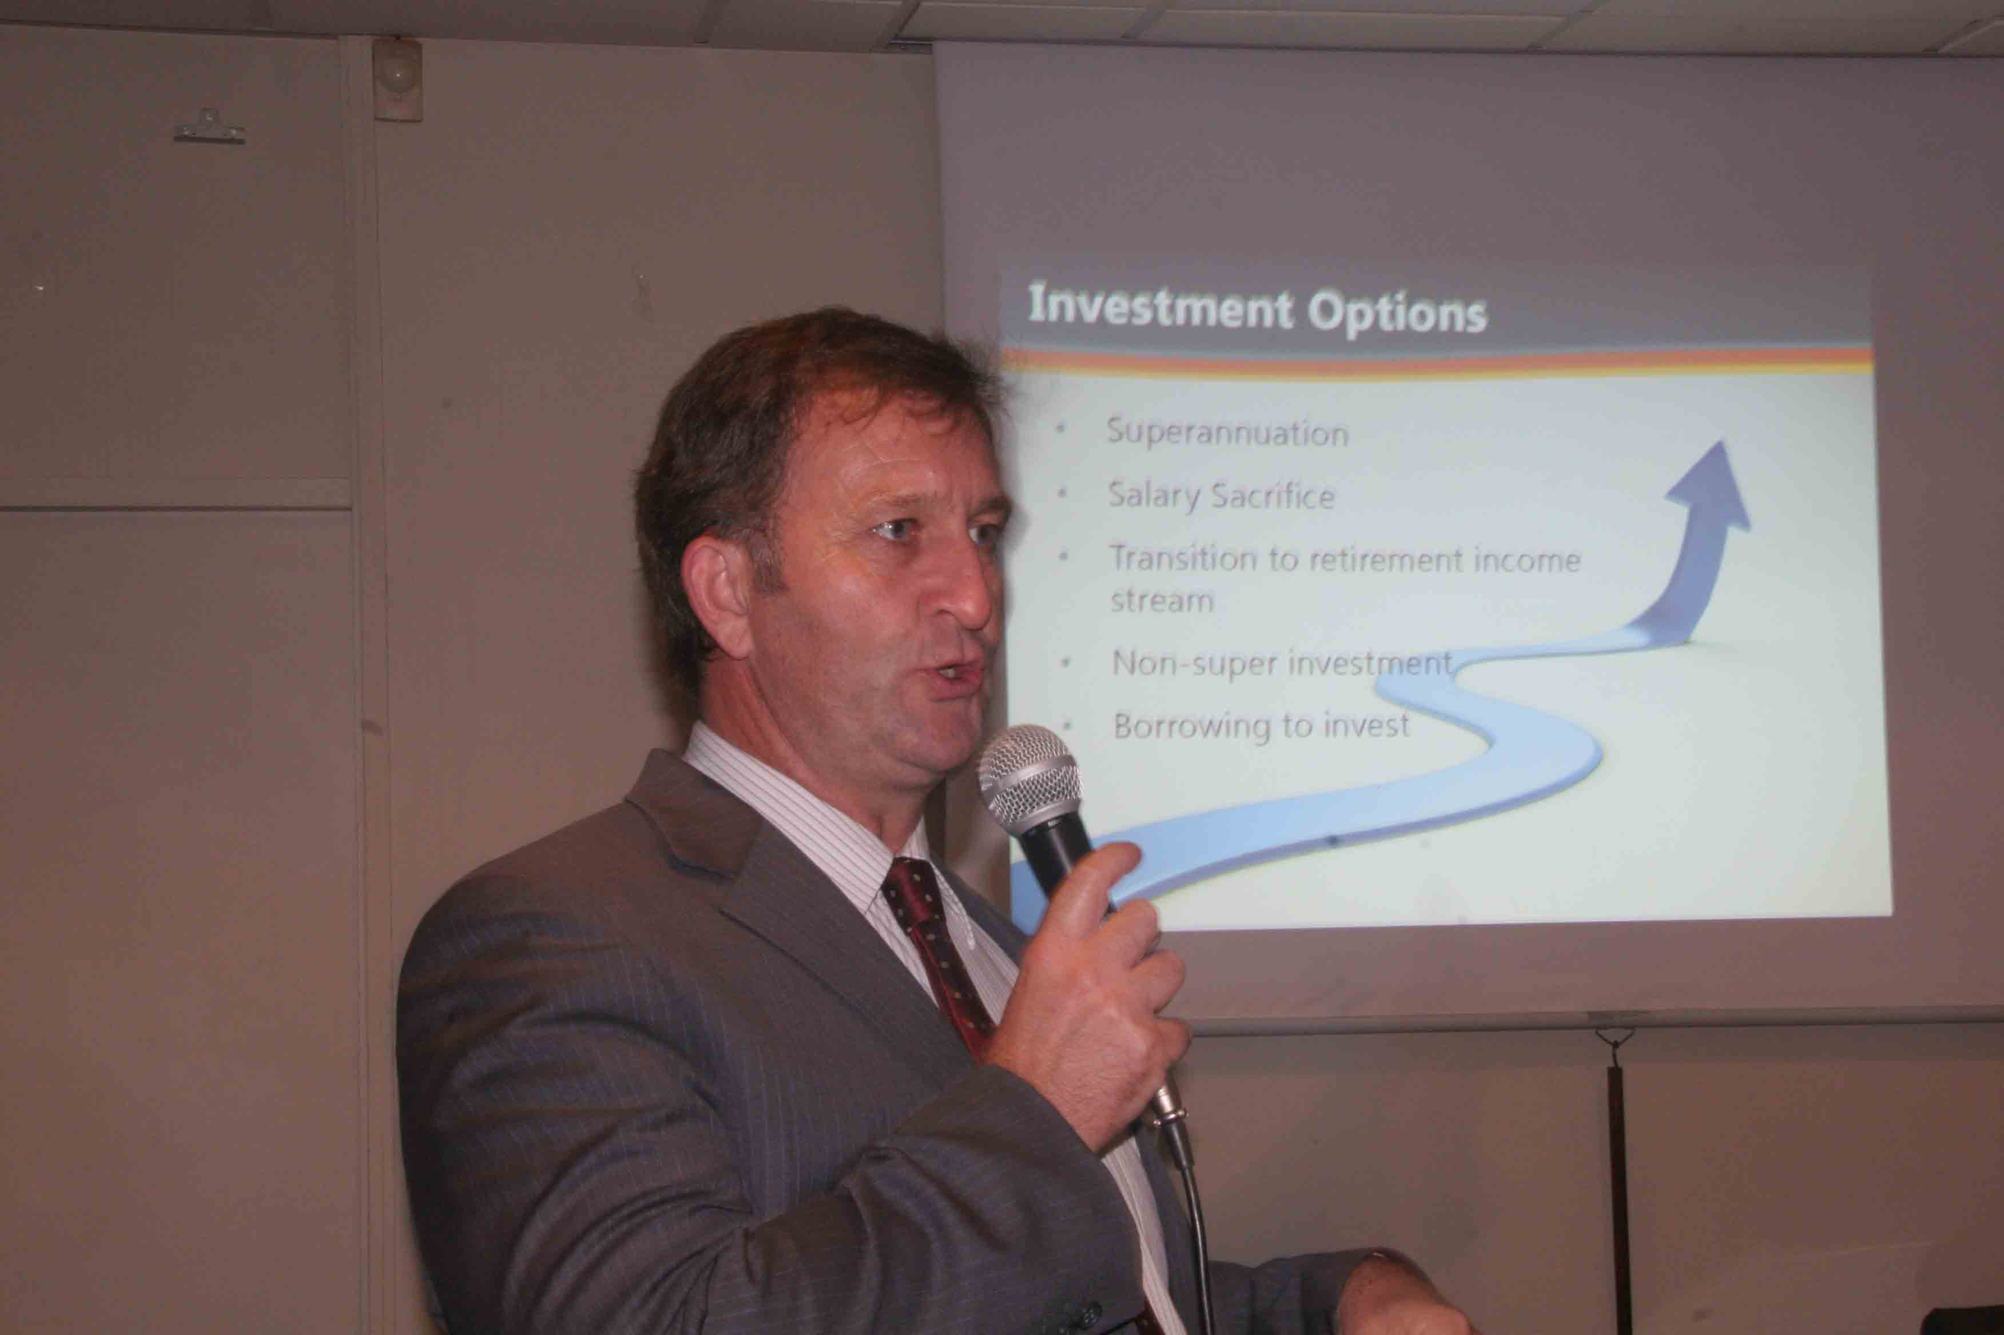
The mission of The Rotary Foundation (TRF) is to enable Rotarians to advance world understanding, goodwill and peace through the improvement of health, the support of education and the alleviation of poverty. The Annual Program Fund is the primary source of support for the programs of the Foundation and supports Matching Grants, GSE, Ambassadorial Scholarships, etc. It is our own charitable fund and the TRF provides integrity in management of funds – providing hope to millions around the world. Rotary changes the lives of so many people everywhere.
Our Club also continues to provide a donation to the Polio Plus program through the recognition of our Speakers throughout the year and this provides an additional $1,000 for Polio Plus.
Educational Programs
Rotary runs a number of educational programs and last year we became involved in the Ambassadorial Scholarship Program. This is a program where Rotary Foundation provides access to a number of university scholarships throughout the world for successful applicants to study in another country. These scholars are ambassadors not only for the Rotary District and the Club that puts them forward but also their country and it is a wonderful opportunity for the successful applicant.
We received an application from a young lady, Bronwyn Lo. Bronwyn was an outstanding applicant and we put her forward to the District for final selection as an Ambassadorial Scholar. Unfortunately Bronwyn was not successful; the District had a number of applications for the Scholarship and all were of a high standard. This year we have received 3 enquiries and we are awaiting the guidelines for the Scholarship Program for 2013 to proceed to the next stage.
Thank you again to all the members, partners and friends of the Rotary Club of Ku-ring-gai for your support of the Foundation throughout this year.
Finally, Caroline thank you for your support and leadership throughout 2011–2012.
Dilys Geddes (Foundation Director)
MEMBERSHIP
At the start of the Rotary year we had 36 members and we have maintained that number. We mourned the loss of PP Frank Fisher and we were also sorry to lose Rotarian Rasma Andrejewskis. Rasma resigned in order to move to Adelaide to fulfil her long held dream of studying medicine. We wish her success in her studies and future career.
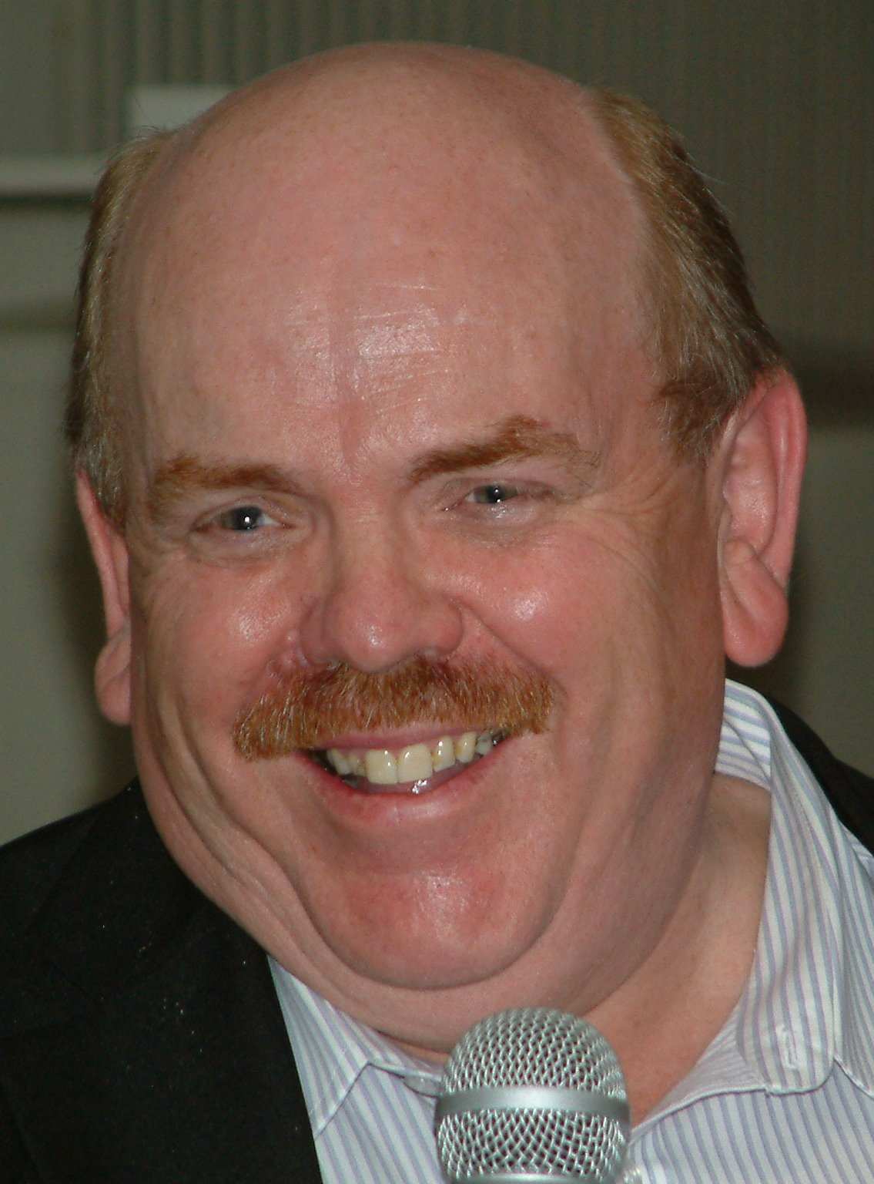
In October we held our first Rotary Awareness Night, which was attended by 10 potential Rotarians invited by our members. Happily, this resulted in the induction of two new Rotarians: Graham Maslen
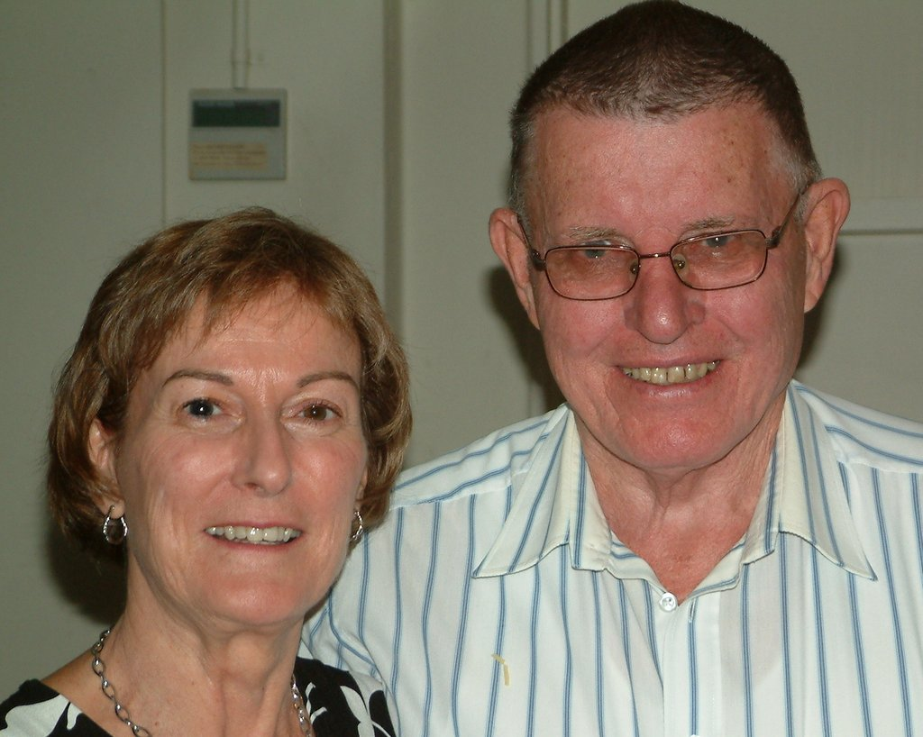
(classification: Taxation Services) and Ross Lambert (classification: Digital Marketing). We also welcomed their respective wives, Penny Lambert and Anne Maslen, to the Rotary family.
In April we held our second Rotary Awareness Night, attended by over 20 local business people. The evening generated a lot of interest in the Club’s activities and resulted in a number of expressions of support, mostly in the form of busy people wishing to provide “hands-on” support for the Club’s projects periodically. We aim to build upon the connections established, so as to increase our involvement with the local community and its involvement with the Club. We will explore new forms of membership, which are currently being trialled by other Rotary clubs, and hope to induct some of our new friends as Rotarians in due course.
During the year a number of our existing members were prevented from attending the Club’s meetings regularly, due to work commitments or illness. Their absence was keenly felt, especially in the contrast between the atmosphere at our reduced size regular meetings and at well attended special events. Although Rotary now recognises that “participation” (which can occur away from our weekly meetings) is more important than mere “attendance”, the message is that all members need to attend Club meetings as frequently as they can, so as to develop and maintain the fellowship on which our Club is founded.
Equally important is that all our members constantly invite friends, business associates and others to our meetings, giving them the opportunity to see Rotary in action and to become Rotarians if they would like to. This is vital to achieving our aim of building the membership to 60, so that the Club has sufficient human resources to carry out all the things that it needs to.
My thanks go to Rasma Andrejewskis, Scott Drake, Geoff Hungerford, Peter Kipps, Tony McClelland, Ted Price, Linda Lam-Rohlfs and Frank White who served on or assisted the membership committee during the year.
Michael Tyler (Membership)
PUBLIC RELATIONS & BOBBIN HEAD CYCLE CLASSIC
The focus of PR for the year revolved around our successful fundraising – the Bobbin Head Cycle Classic. The event required so much of our marketing effort, that we were not able to do other PR. However, the event was so successful and involved so many of the community, with so much publicity, that our PR efforts could not have been put to better use. In coming years our club and partner club Turramurra will get an enormous publicity boost each year, as the event becomes an iconic community event.
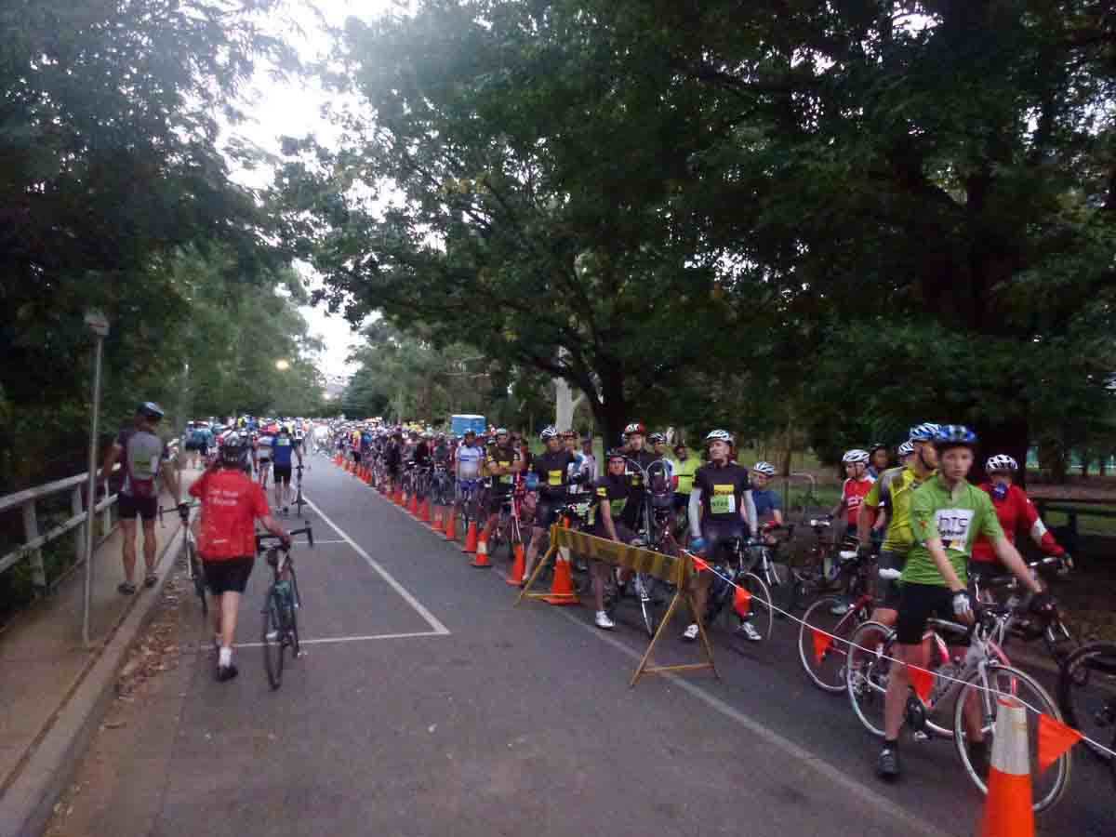
The event featured 100k, 50k and 15k rides which started at Karuah Oval in Turramurra, went through Bobbin Head and on to Berowra and Calga. As part of our marketing effort we were able to combine traditional and digital methods to great effect. The digital part started with Bob Ivey putting much of his own time into developing a very professional web site, to provide information, promotion and registration. Our online efforts continued through use of Facebook and email, ending with a productive web survey.

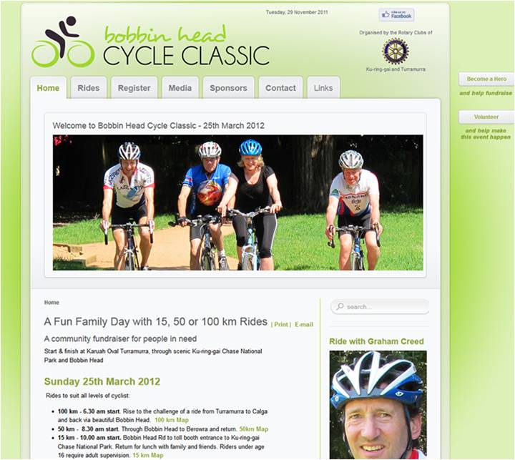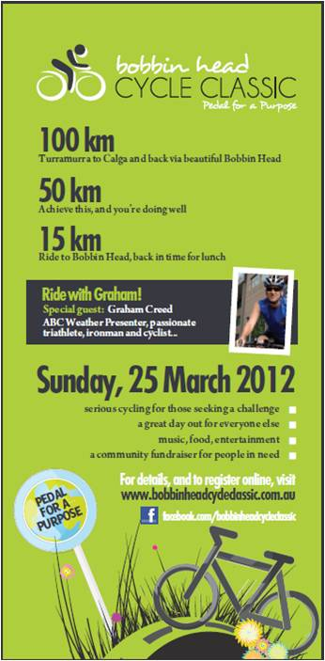
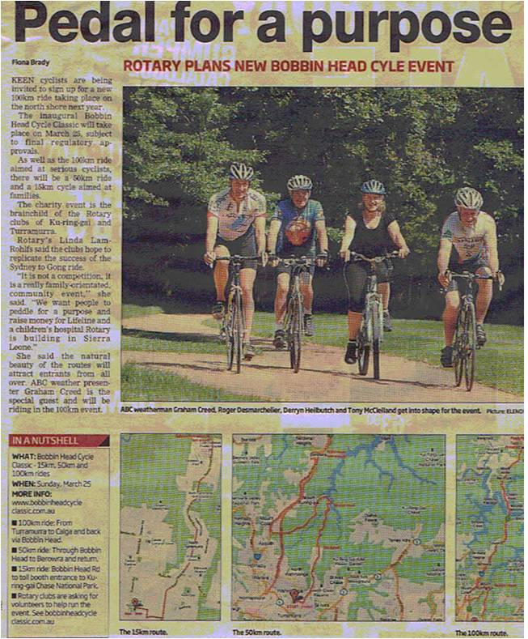
At first, to get the word out, we divided the local area into 5 Marketing Zones: Ku-ring-gai, Hornsby, Ryde, Warringah and Willoughby. Each zone had a “Zone manager” appointed. Armed with posters and books of flyers, their main task was to get the event publicised in bike shops, associated bike clubs, health clubs, coffee shops and gyms. Registrations slowly started to come in.
The first major boost to numbers was when Tony McClelland and Linda Lam-Rohlfs handed out 4000 flyers to riders finishing the “Gong Ride”. Every rider was a prospect for our event. Focused marketing indeed! Hits on the web site immediately went from less than 10 to over 40 a day with a corresponding increase in the rate of registrations.
By then Linda had approached a local celebrity, Graham Creed, ABC weatherman, who agreed to support the event. He is a keen cyclist, lives in the area and featured in several of our photo shoots. Linda was also able to get us publicity in the North Shore Times and Advocate.
We then set up an event Facebook page and experimented with ways of initiating a discussion with our “Fans”. Adele Mitchell took this over and put much effort into building two-way interaction with the community.
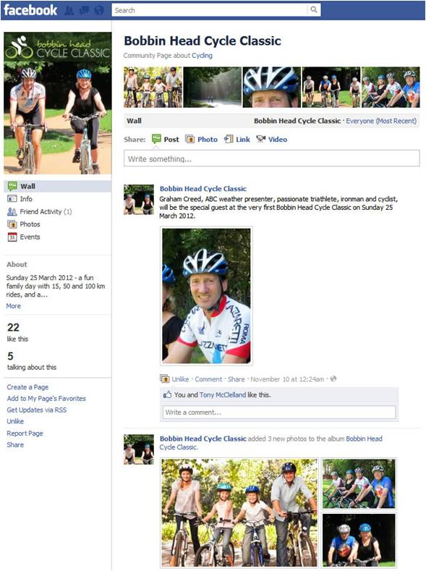
Two months out we started Facebook Advertisements and the results were extraordinary! In the end our Advertisements appeared on 50,000 Facebook sites at very low cost. The registrations climbed again and never looked back.
We had several large signs made up and were able to “park” these on the backs of trailers along routes popular with cyclists. Geoff Hungerford also took on the task of putting up banners in council banner spots along main roads. In addition Adele emailed every bike shop and public bike club in NSW with an invitation to participate. The community certainly knew the event was on!
The combination of these traditional and new marketing methods ended up being so successful and brought so many riders that we had to close registrations early to ensure the event remained manageable. On the day we announced the closure 80 people rushed to register!
The day went off with hardly a hitch. Many thanks to 120 Rotarians, partners and volunteers who played their part as Road or Drink Stop Marshals or helped out at Karuah Oval.
After the event we asked riders and volunteers to complete a web survey which yielded invaluable feedback. Response was largely positive, but also yielded invaluable information on where we can improve out management for next year. This will help us to refine our marketing in 2013.
The marketing task should be easier in 2013 as we have 900+ riders and 600 Facebook fans who we can contact as soon as we open registrations to invite them to take part. A year ago we had none.
We are indebted to Michael Robertson of Turramurra who initiated the event, planned the ride and did most of the liaison with the authorities over an extended period. Tony McClelland (Registration) and Roger Desmarchelier (Logistics) sat on the planning committee and made big contributions. Many other club members played their part, too many to mention by name.
In the end many people in both clubs were involved in our marketing, but special thanks must go to Linda Lam-Rohlfs, Adele Mitchell and Bob Ivey, who played a major part in putting the event on the map.
Peter Kipps (Bobbin Head Cycle Classic and PR Chair)

PROJECTS & COMMUNITY SERVICE
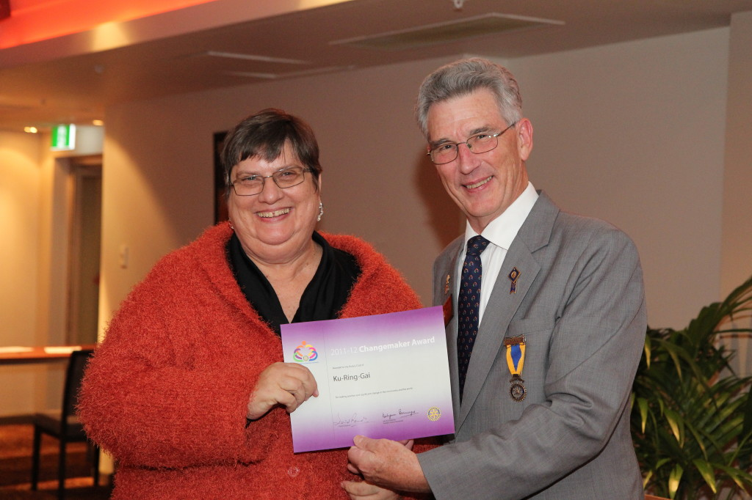
As part of Community Service, John Thompson (Chairman) unfortunately had to take leave of absence to attend to his business early in the year. In line with President Caroline’s strategic direction for 2011/2012, our annual plan took into account our “business as usual” commitments and increased involvement with the local and wider Australian community through service projects. For this we were awarded a Changemaker Award. In three broad areas – major projects, ongoing programs and community service focused “innovations” – we took on and accomplished a lot; but we are only too well aware of how much more still needs to be done: a springboard for further action in 2012/2013.
The Community Service team were: Roger Desmarchelier (Deputy Chairman); and Committee Members Lou Coenen, Ivan Cribb, Scott Drake, Wally Forbes, Michael Midlam and Ted Price.
Apart from specific on-going community collections such as Daffodil Day and Red Shield, our funding efforts were directed to our Rotary sponsored projects such as Polio Plus, Rotary Against Malaria, and our Club projects such as Lifeline, Clarke Road School, Eagles RAPS and many others.
The regular community projects that fund these activities include:
Gordon Markets
These are held on the second Sunday of every month and have provided us with a steady flow of funds. With our co-sponsors, Rotary Club of Turramurra, the steering committee has put in place more prominent advertising (8 new banners), a better quality and mix of stallholders, and simpler administration and logistics for all concerned. Our effort also included a Rotary membership stand managed by Linda Lam-Rohlfs. The returns to our Club were $15,000 this year.
Special thanks must go to committee member Geoff Hungerford; a small band of regulars led by Frank White, Wally Forbes and Graham Timms, who set out our new signage each month come rain, hail or shine; and indeed to all in our Club who gave up precious chunks of their weekends for Market PR/patrol purposes.
Rotary Health-Related and other Fund-Raising Projects
Under this general umbrella heading we helped raise funds and made donations for a number of appeals and were involved in the following community projects:
• For Daffodil Day in August at Pymble Station (with thanks to organiser Ross Egan);
• For Christmas gifts, through “Trees of Joy” at West Pymble Shopping Centre (with thanks to organiser Ted Price);
• Through the sale of Rotary Christmas cakes and puddings (with thanks to Linda Lam-Rohlfs and Ted Price). This netted $3,000.
• For Bowelscan collections. This netted $3,720.
• Providing a BBQ at the West Pymble Swimming Pool.
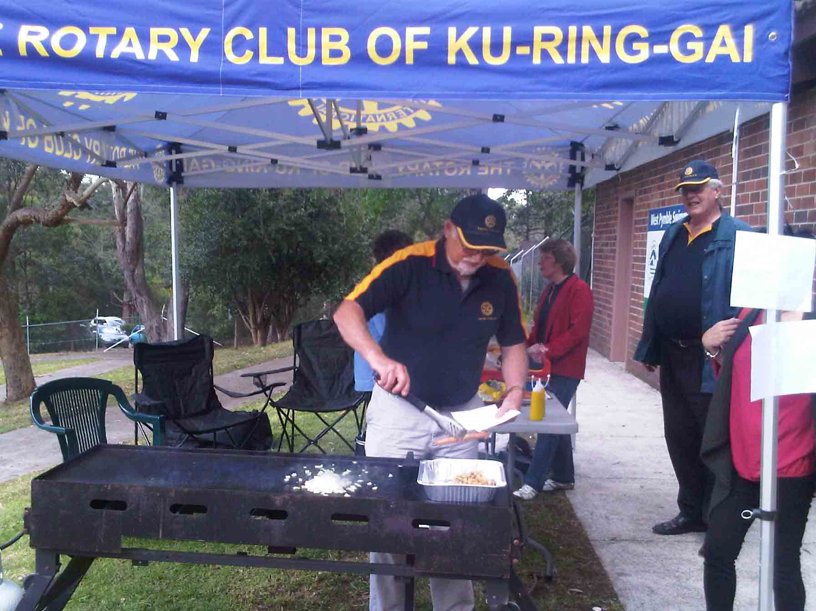
• Lifeline support and Book Fair – loading and transport of books from storage.
• For the Red Shield Appeal in June (with thanks to organiser Chris Hoch).
• Studio ARTES was donated a further $3,000 towards their bus to transport the students.
• Carers’ Night: Irene Kennedy & Scott Drake led our event this year – a wonderful occasion for recognising unsung heroes in our community, and truly inspiring. A special feature this year was to recognise Bob Vernon’s 10 years of coordinating this event.
• A Farmers’ Market to complement the monthly Thornleigh Market has been investigated. A meeting with Council has highlighted the need for close coordination on a possible site at West Pymble Shopping Centre.
In summary, “Community Service” is what we all stand for. It’s inspiring, it can be visionary and it brings us back to our grass roots. As we learned during our working bees, it gives us incredible opportunities also for further bonding and fun.
As our TEAM motto suggests:
Together, Everyone Achieves More.
My thanks to all in our Community Services team and our Club for their efforts in making this year’s contributions worthwhile.
Ross Egan (Projects Director)

AVENUES OF SERVICE: VOCATIONAL
As Irene’s work commitments took over Monday nights, Caroline organised a Pride of Workmanship awards evening which Ted Price admirably presented. We were delighted to award certificates to nurse Samantha Hawkins from Lady Davidson Private Hospital, hairdresser Debbie Walker from Boffa Hairdressing and mechanic Sachin Suneram from Caltex Garage. A bonus from this night was that representatives from Caltex and Lady Davidson were so enthused by talk of our Cycle Classic that they entered riders and Lady Davidson Hospital even became one of our sponsors.

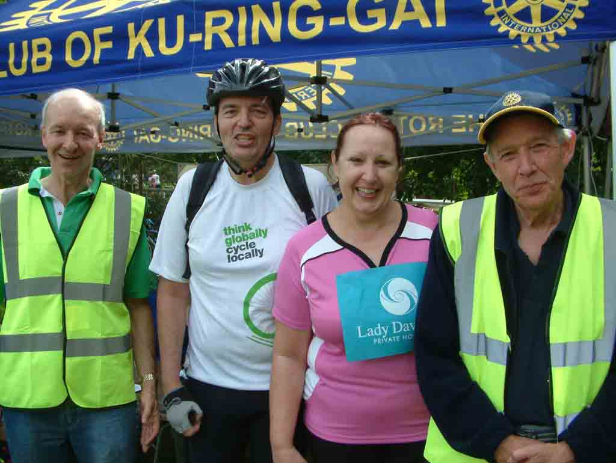
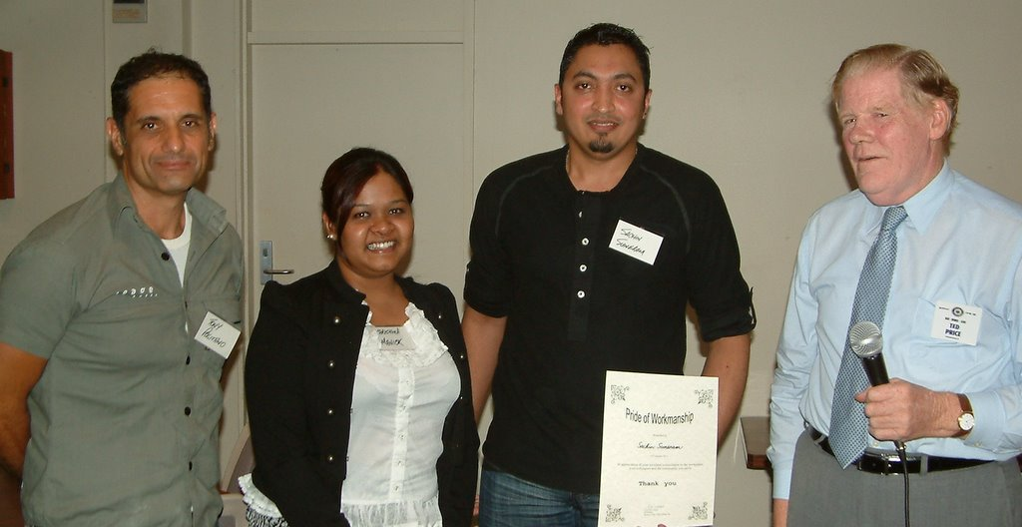
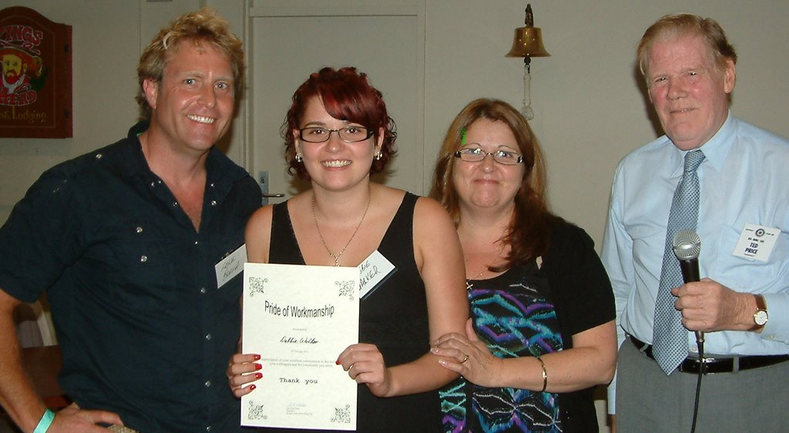
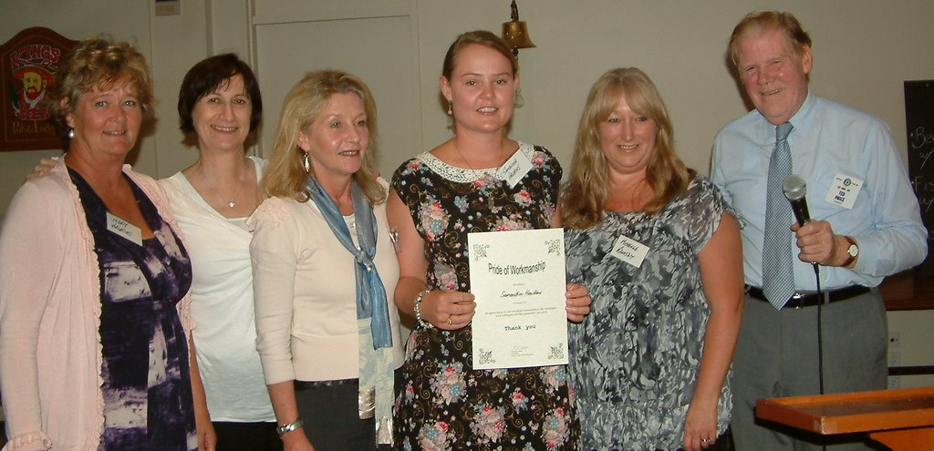
AVENUES OF SERVICE: INTERNATIONAL
The Club’s International Service this year was important, useful and not enough. The story of the little girl and the starfish is relevant here. A young girl, walking along a beach was throwing back into the water some of the starfish which had been stranded on the shore. An adult walking by asked: “Why are you doing that? There are so many of them you can’t make a difference.” The girl threw another one back into the water and said, “I made a difference for that one.”
This year the Club continued to support a number of important projects, all of which have made a sig-nificant difference.
Rotary Oceania Medical Aid for Children (ROMAC)
ROMAC arranges and manages lifesaving and/or dignity restoring surgery for children from developing countries. This work transforms the lives of the children ROMAC helps by correcting deformities either from birth or caused by accident. ROMAC is often the only hope for people who would otherwise be condemned to a sub-standard life. We gave $1,000.
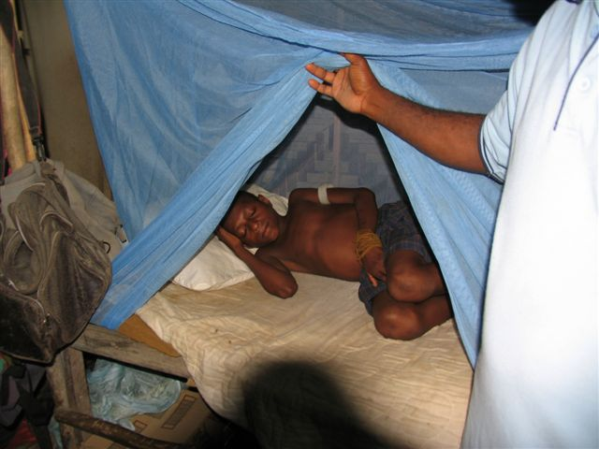
Rotarians Against Malaria (RAM)
RAM provides bed nets to vulnerable communities. Impregnated bed nets which kill malarial mosquitoes are a very effective way of preventing the spread of this dangerous disease. The RAM Committee recently thanked the Club for our long term support. We gave $1,000.

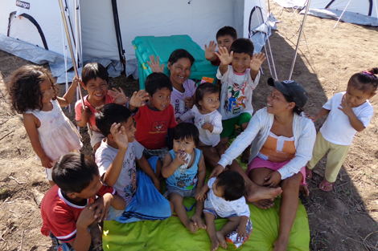
ShelterBox
If worldwide peace broke out tomorrow, the need for ShelterBox would continue. The need will never go away. As long as there are natural disasters there will be a need for ShelterBox. This brilliant concept, brought to life by one Rotary Club, has now provided shelter, warmth and dignity to over a million people worldwide. It all started with one club, Helston Lizard in Cornwall, UK in 2000. The power of an idea supported by the commitment of Rotarians demonstrates again the cumulative value of what we do.
A mother in Peru outside her “home”
This year we donated 4 ShelterBoxes, at a cost of $4,000, which will provide hope to at least 40 people who have lost everything, probably from a natural disaster. PLC Pymble Interact Club have also raised $1,000 and donated a ShelterBox. Visit www.shelterboxaustralia.com.au to follow our ShelterBoxes (each one is numbered). This amazing project has grown and become so well known that Rotarian donations have now been matched by outsiders, not only doubling our efforts worldwide but also involving more people and promoting the work of Rotary.

School of St Jude
We have continued to support the School of St Jude in Tanzania on a smaller scale than in earlier years. Nevertheless, our continuing sponsorship funds the operation of two residential rooms meaning that 16 children are housed and cared for by the application of our funds. This helps those 16 children get greater value from their education because they are well fed and do not have to endure hours of exhausting travel each day. Our $1,440 is helping to eliminate poverty through education. What could be more worthwhile? Visit www.schoolofstjude.org
Bo Children’s Hospital
Adele Mitchell has continued to serve on the committee of this outstanding project with members of the Rotary Club of Turramurra and International House. The Bo Children’s Hospital was a major beneficiary of the Bobbin Head Cycle Classic and was not part of our International budget this year.
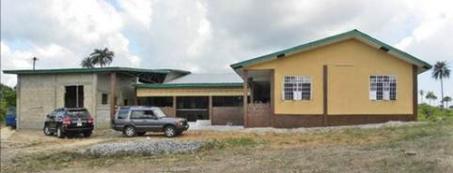
School for Life, Uganda
Imagine two students 21 years old who decide to build a school in Africa, and then do it! For the second time the Club has met this phenomenon. We had hoped to be able to help with a Matching Grant from The Rotary Foundation this year but for a number of reasons beyond our control that was not possible. That has been fortuitous because we now have the opportunity to play a significant role in a much bigger project next year. Visit www.schoolforlife.org.au
Manjeri School, Uganda
In 2010 we were major donors to another school project in Uganda. We now have the opportunity to assist Jesse Buckingham and Andrew Thomas by helping them achieve tax deductibility for their project. This will require some administrative effort but no funds from the Club. It will, however, provide a major boost for the project.
We have also been able to introduce the four outstanding young people behind these projects to one another so that they can explore ways of cooperating for the benefit of both projects.
Committee
This year’s committee members were: Adele Mitchell, David Forsythe, Peter Tang, John Aitken and Rasma Andrejewskis. Sadly for us, Rasma moved back to Adelaide during the year and we all wish her well with her study.
Greg Newling (International Chair)

AVENUES OF SERVICE: NEW GENERATIONS
Under the heading of New Generations, Rotary’s Fifth Avenue of Service, in this year’s District Directory is this statement which comes from the Manual of Procedure 2007 page 95: “It is the responsibility of each Rotarian to prepare the New Generations – all young people up to the age of 30 – by improving their life skills to ensure a better future. All clubs and districts are encouraged to undertake projects that support the fundamental needs of the New Generations: health, human development, human values, education and self development.”
This is a powerful and challenging statement. I believe our activities in the past year encouraged and supported young people in many areas, both through programs organised and administered by our Rotary District 9680 and other programs conducted by outside organisations.
Rotary Youth Exchange
The year started with a visit from past Youth Exchange Student, Moragot Kongkiatkul, who was visiting Sydney with her parents. Moragot reminded us that when she came here in 2005 aged 15 she had almost no English. Now she has finished her university degree and hopes to continue her studies or get a job overseas using her now fluent English. She has come a long way! Moragot and her parents visited some of her host families, she and her mother patted koalas and kangaroos at Koala Park and her father enjoyed golf with some of our Club’s golfers. Moragot also explained how impressed she was during her year with our Club that our members were happier to “give” than to “get”. Michael and Louise Tyler hosted a lunch for Moragot and her parents as well as having them to stay and several of us enjoyed the chance to catch up with them.
Rotaract
Greg and I joined in the Rotaract District Changeover and Rasma and Greg attended the Charter Night of Lower North Shore Rotaract Club. Members of this new Club are keen to grow their Club and assist us where they can, and they have already helped at Clarke Road School’s Celebration Day and our first Bobbin Head Cycle Classic. Their Charter President, Jacqui Fogarty, attended one of our recent meetings and spoke enthusiastically about their achievements and their plans for the future. Roger, Malcolm and Ross Lambert attended one of Crosslands Rotaract Club’s meetings and were impressed with their energy and activities.
Interact Club at PLC
Caroline and I had a very good meeting with some Interact Club members and teachers in September and some of them visited one of our meetings. They have been very active in fundraising for different charities during the year and in May we found out they had raised enough funds for a ShelterBox which is a fantastic effort.
Clarke Road School, Hornsby
We had good contact with Clarke Road School during the year, partly through my position as the Community Representative on their School Council. Several of us spent one afternoon cooking sausages at their Celebration Day for students, ex-students, staff and families before their old school was demolished and they temporarily relocated across the Road to Hornsby South School while their new school was being built. The staff and parents were very appreciative of our efforts and they were able to enjoy the day more because they did not have to worry about feeding the crowd.
I represented our Club at their Presentation Day and again, it was inspiring. Every child was recognised and received a certificate – three examples were improvement in computer studies, getting better at reading street signs to navigate their way, or simply bringing a smile to school every day.
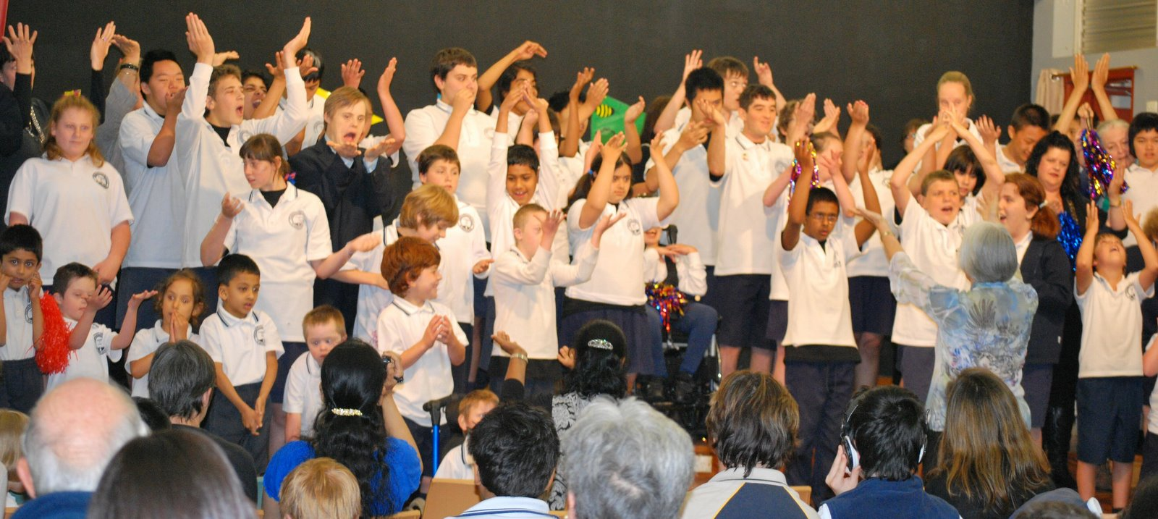
Our Club donated the Rotary Role Model Award and I was honoured to present it to Radhika Koroth who is Vice Captain in 2012. We were thanked by the Deputy Principal for the support we give the school, and that famous BBQ was mentioned again.
Youth Insearch
Youth Insearch is a community organisation that focuses on resolving adolescent issues at a peer level. Two young co-ordinators, Nicole Clark and Briar Ward, were guest speakers at one of our meetings and opened our eyes about the problems some young people face and how they benefit from Youth Insearch weekend programs. We decided to assist with catering again for one such camp and in November Linda, David, Greg, Michael and Louise Tyler and myself helped cater at their Christmas Camp at Morisset. There were 56 teenagers aged between 12 and 18, and 14 leaders and support people, so we were feeding 60 each meal plus ourselves. This time we were working with a chef and that made our job much easier.
The program included sessions on building self-esteem, the importance of hugs, practical information on adolescent issues, drug and alcohol hassles, assault and grief. On a lighter note, finding hidden talent and building confidence in an entertainment segment, and having fun in a wet and muddy obstacle course in one of the rare sunny periods on Saturday produced many laughs.
The highlight for me was on Saturday night when we re-arranged the tables and decorated the dining room for Christmas festivities and a traditional Christmas dinner. The looks on their faces when they walked into the room for dinner and we heard the “oohs” and aahs” made it all worthwhile. To see Santa arrive and give everyone a gift was the icing on the cake. Many of them gave him a hug or sat on his knee! For some of these young people it would have been the only Christmas they had.
Benefic Awards
This is an annual award for one Year 9 student from Turramurra, Ku-ring-gai and Killara High Schools who displays “a favourable influence” amongst their peers. A perpetual trophy and book voucher was presented to each of the students and my thanks go to Caroline and Roger for representing our Club at Ku-ring-gai and Turramurra. I had the pleasure of presenting the award at Killara High School where the speeches by their Principal, Dr Mark Carter, and their outgoing Captain were inspiring. The music from their Stage Band was fantastic and a small jazz group from Killara will be playing at our Changeover Dinner.
Rotary Youth Leadership Award (RYLA)
RYLA is a residential leadership training seminar for 18–25 year olds which is conducted for a week in January each year and this year we sponsored Koz Yamada. Koz is also a member of Lower North Shore Rotaract Club and she found RYLA a positive experience and gained an insight into different styles of leadership. Koz visited our Club before RYLA and also came back afterwards and talked about her RYLA experience. Greg, Emyr and I attended the RYLA dinner which was very stimulating with Michael McQueen talking about communicating with Gen Y’s and all the young RYLA participants obviously enjoying the week.
Model United Nations Assembly (MUNA)
This year MUNA was held in March and we sponsored one team from Pymble Ladies’ College, and they financed one team themselves. They represented the countries of Nigeria and Iran in the Assembly wearing national costumes of their respective countries and debated international issues from their country’s point of view. Caroline, Greg and I visited during the weekend and were impressed. Elissa Zhang and Christine Wang, accompanied by their teacher, Daisy Staniford, came to our Club and talked about their experiences and how it helped them appreciate other cultures and attitudes.

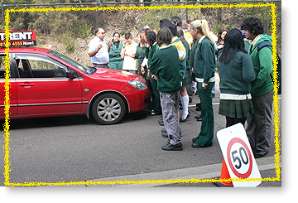
Rotary Youth Driver Awareness
Wally Forbes, Bob Ivey, Graham Timms and Tony McClelland assisted with the Rotary Youth Driver Award (RYDA) program in May when a group of students from Ku-ring-gai Creative High School participated. They were impressed with the program and the way the road safety message was delivered to the students.

Life Education
Life Education is the largest non-government provider of drug and health education to children and young people, and their families and communities Australia-wide. Many of you will have seen their trademark, Harold the giraffe, on one of their vans at a local school. We were pleased to support their great work again with a donation.
Camp Breakaway
Camp Breakaway on the Central Coast is committed to enhancing the lives of people with disabilities and at the same time allowing relief for their families and carers through their respite camps. This year we covered the cost of a young sibling of a child with high medical needs attending a respite camp where they can briefly escape their home environment of care and responsibilities and just be “children”. They would be spoiled and fussed over and enjoy a week of activities and entertainment. Amongst other benefits, they also have the chance to meet and form friendships with others who are in a similar situation at home.
Eagles RAPS
Perhaps the most exciting achievement for our Committee this year was the provision of a second-hand bus to Eagles RAPS at Doonside. This came about through my position on the School Council at Clarke Road School when I learnt that they had finally raised enough funds for a brand new bus.
They were therefore trading in their old one. We knew that Eagles RAPS were desperate for a bus, and so for the trade-in price of $4000 our Club was able to negotiate a purchase and donate it to Eagles RAPS.
On Friday 18 May Greg and I had the pleasure of handing over the keys to Marten Wynd of Eagles RAPS. A more formal handover will be done in a few weeks. Funding for the bus was covered by $1025 from New Generations budget, $975 from the Christmas party and $2000 from a Rotary Foundation District Simplified Grant. Sally, Marten and Scott at Eagles RAPS are excited and very grateful for the bus because it will enable them to take young people on educational excursions which are not possible at present. This is a win for everyone.
As you can see, New Generations has had a busy year. Our Committee was small but with the assistance of other Club members we achieved a lot and I like to think we impacted for good on the lives of many young people. I would like to thank Tom, Emyr, Bob and Lou for their support. It continues to be a learning experience for me and I look forward to our Committee being able to make a positive difference in the lives of more young people in the coming Rotary year.
Joy Newling (Youth Chair)

