ROTARY INTERNATIONAL

2011–2012

[](http://www.rotary.org/RIdocuments/graphics/theme11-12_en.zip)

**District 9680**

KU-RING-GAI

**KU-RING-AI CLUB**

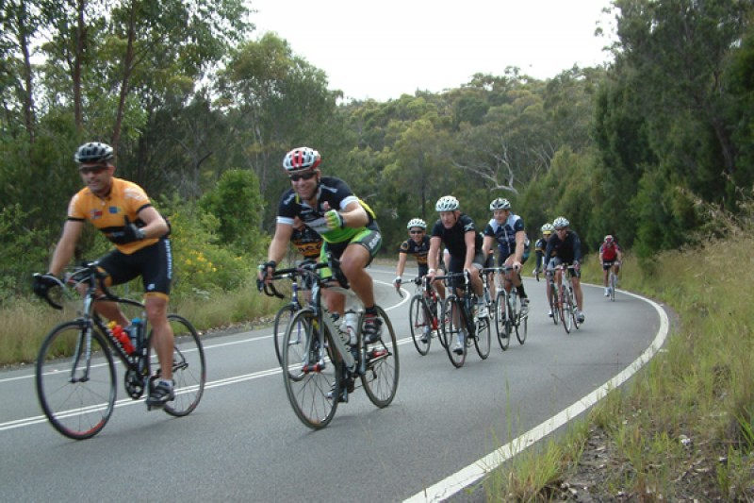

**ANNUAL REPORT**